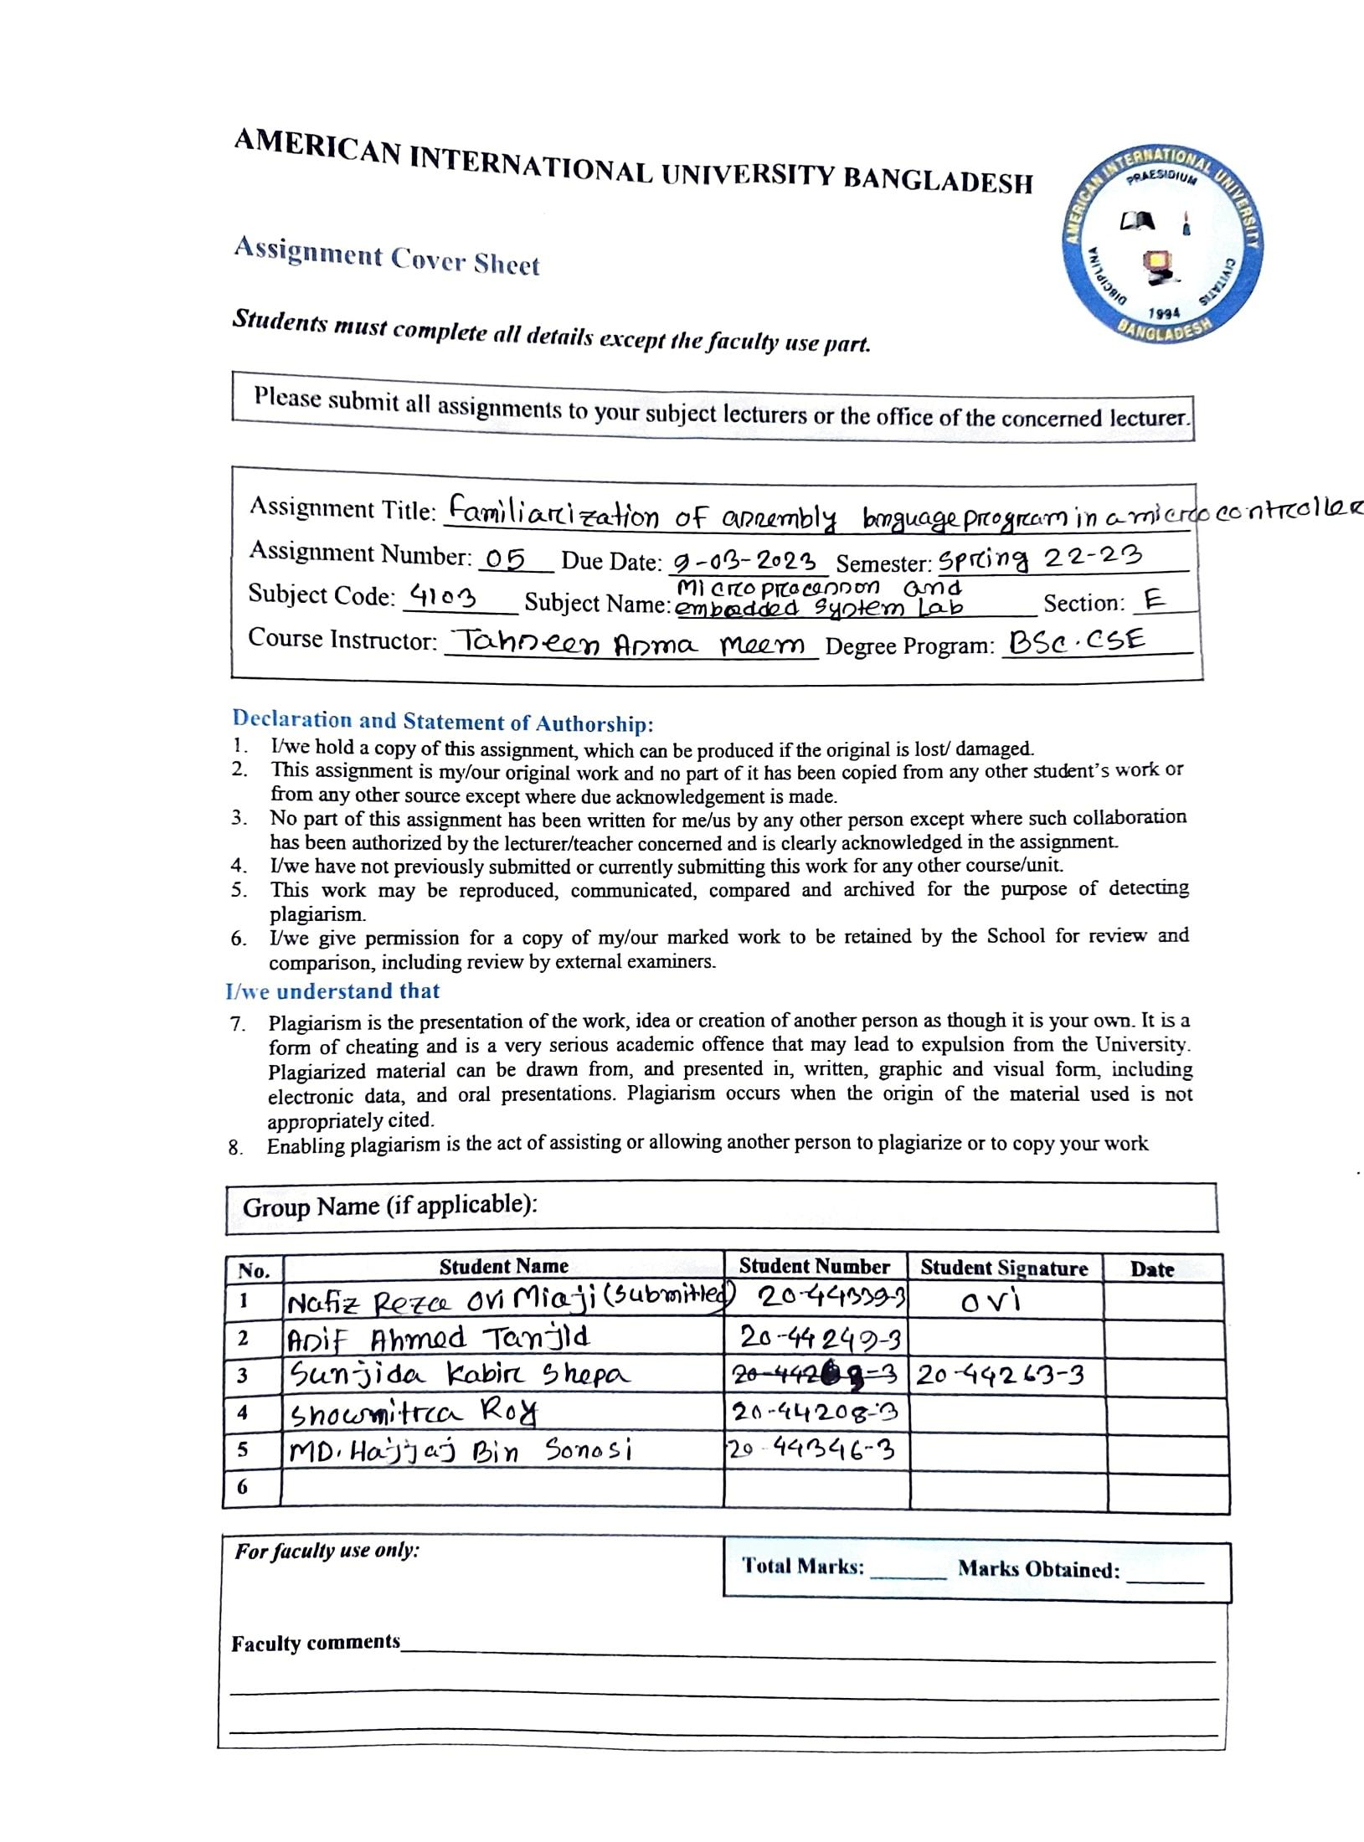







**Source code:**

**.ino file:**

**//-----------------------------------**

**// C Code: RGB LED ON/OFF via Buttons**

**//-----------------------------------**

**extern "C"**

**{**

**void start();**

**void btnLED();**

**}**

**//-----------------------**

**void setup()**

**{**

**start();**

**}**

**//-----------------------**

**void loop()**

**{**

**btnLED();**

**}**

**.S file:**

**;------------------------------------------**

**; Assembly Code: RGB LED ON/OFF via Buttons**

**;------------------------------------------**

**#define __SFR_OFFSET 0x00**

**#include "avr/io.h"**

**;------------------------**

**.global start**

**.global btnLED**

**;=============================================================================**

**start:**

**SBI DDRB, 4 ;set PB4 (pin D12 as o/p - red LED)**

**SBI DDRB, 3 ;set PB3 (pin D11 as o/p - green LED)**

**SBI DDRB, 2 ;set PB2 (pin D10 as o/p - blue LED)**

**CBI DDRD, 2 ;clear PD2 (pin D02 as i/p - red button)**

**CBI DDRD, 3 ;clear PD3 (pin D03 as i/p - green button)**

**Simulation:**

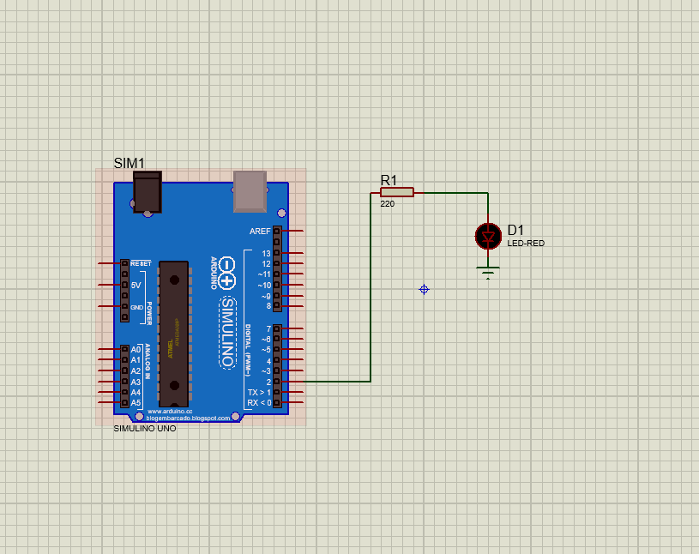

Fig: LED is in off state

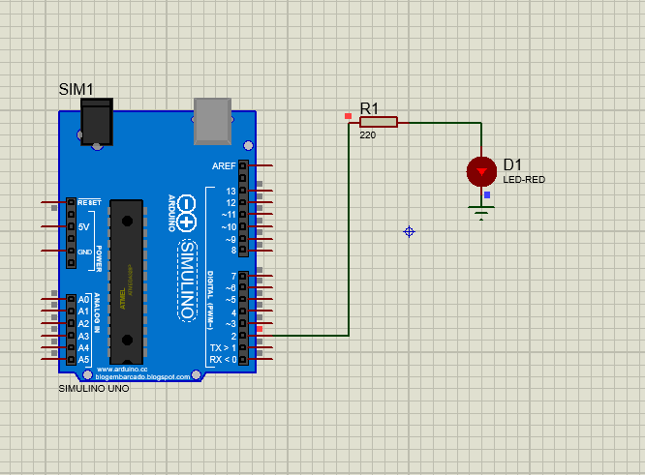

Fig: LED is in on state

**Hardware Implementation:**

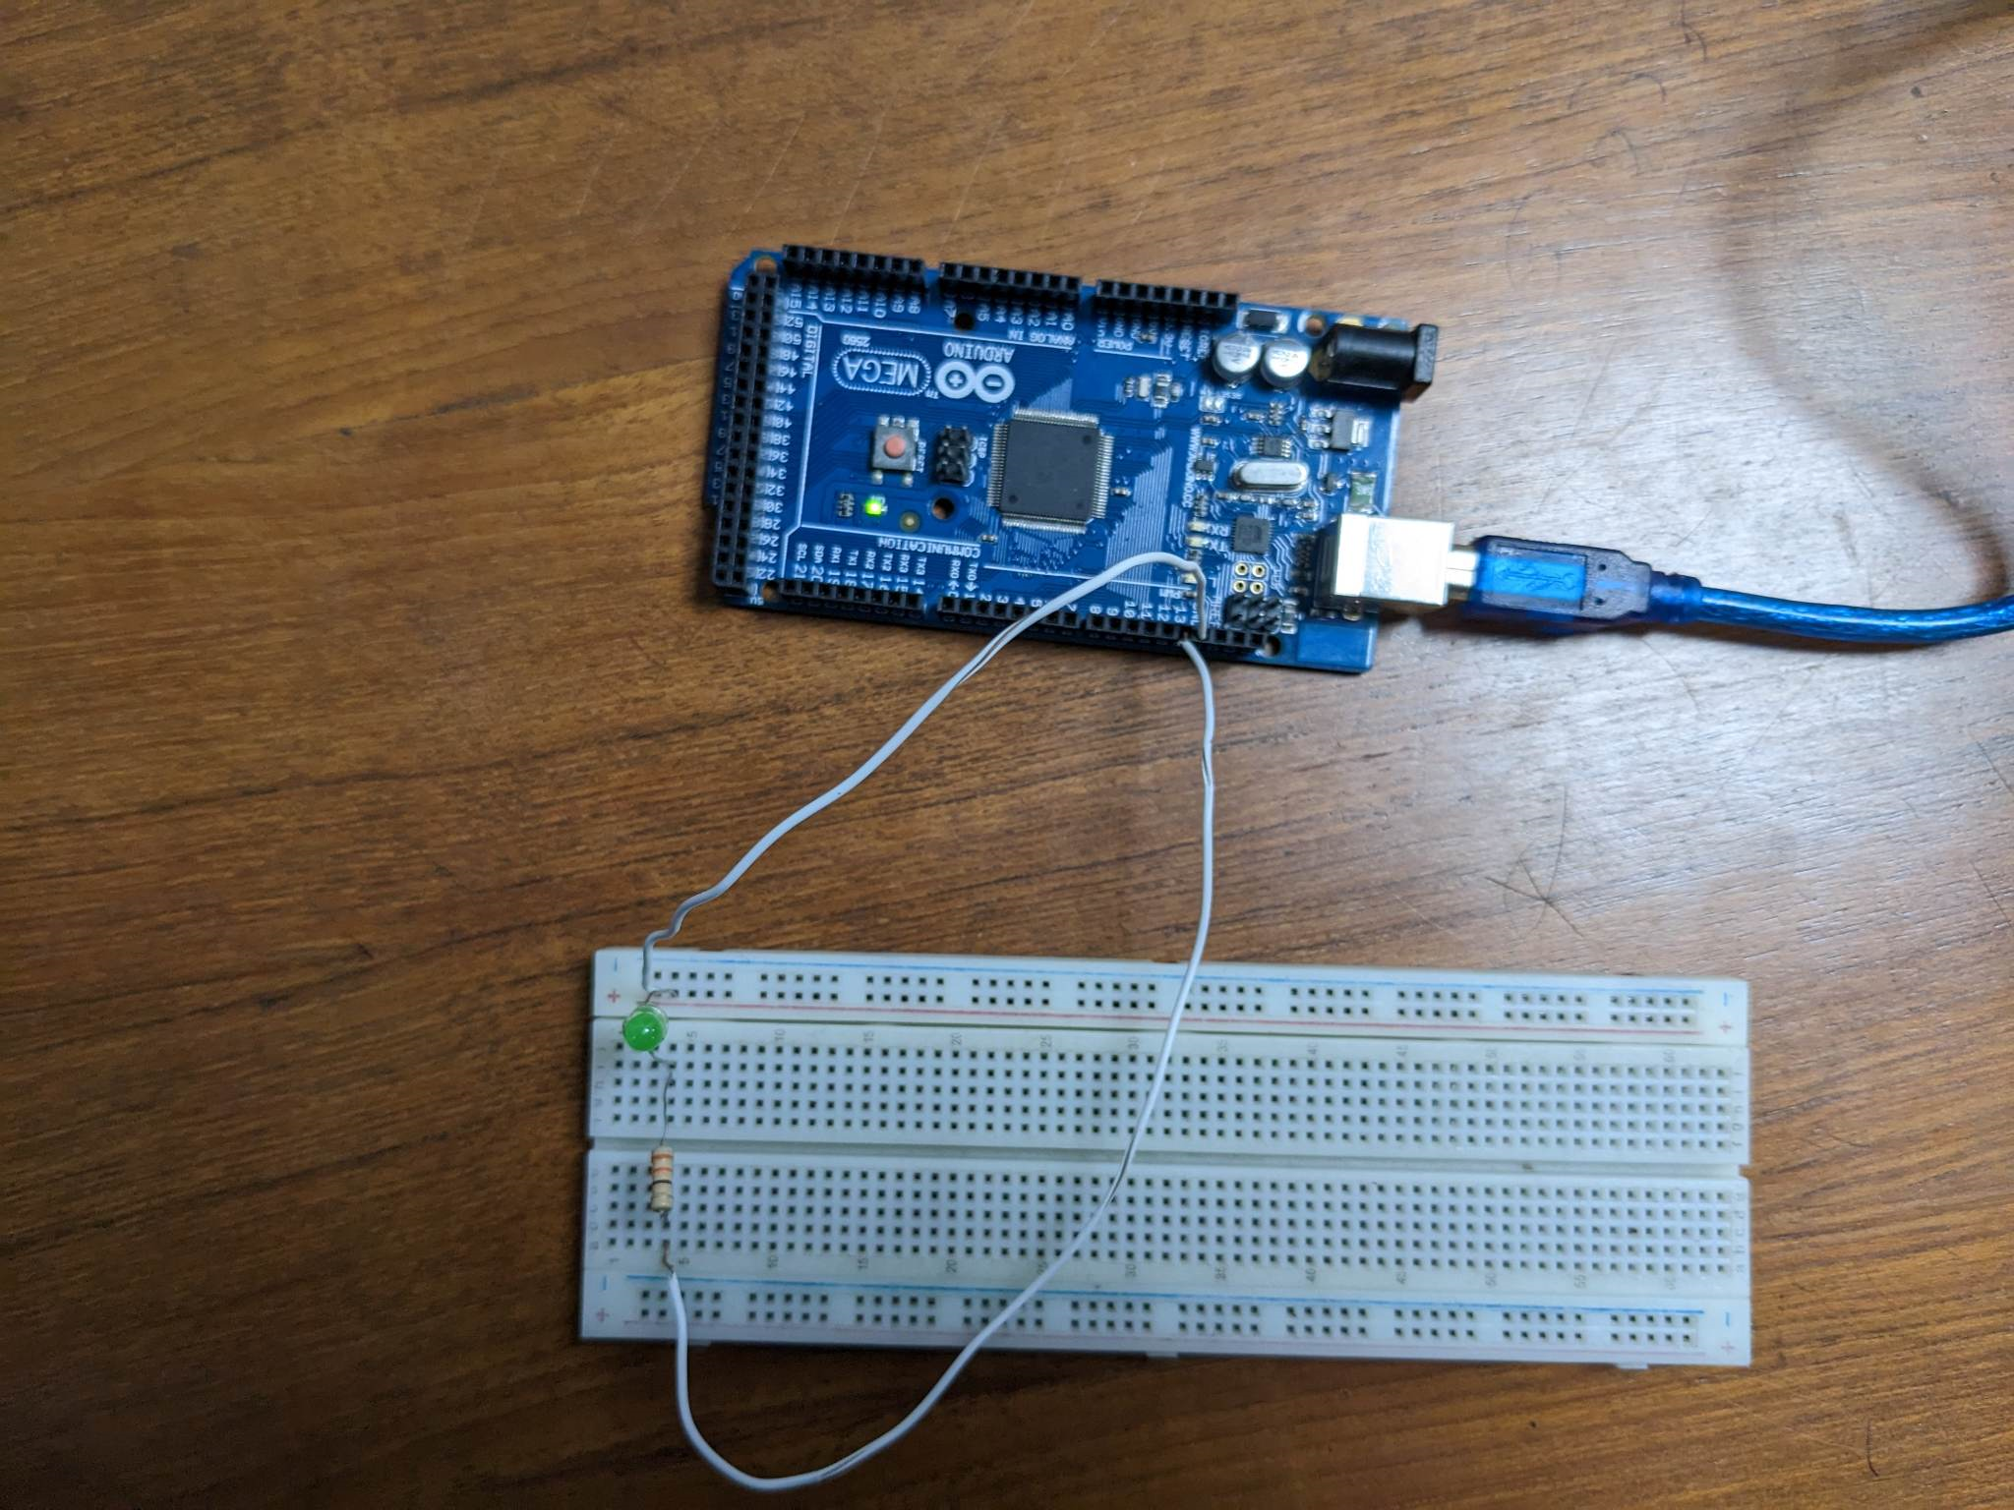

Fig: LED is in off state

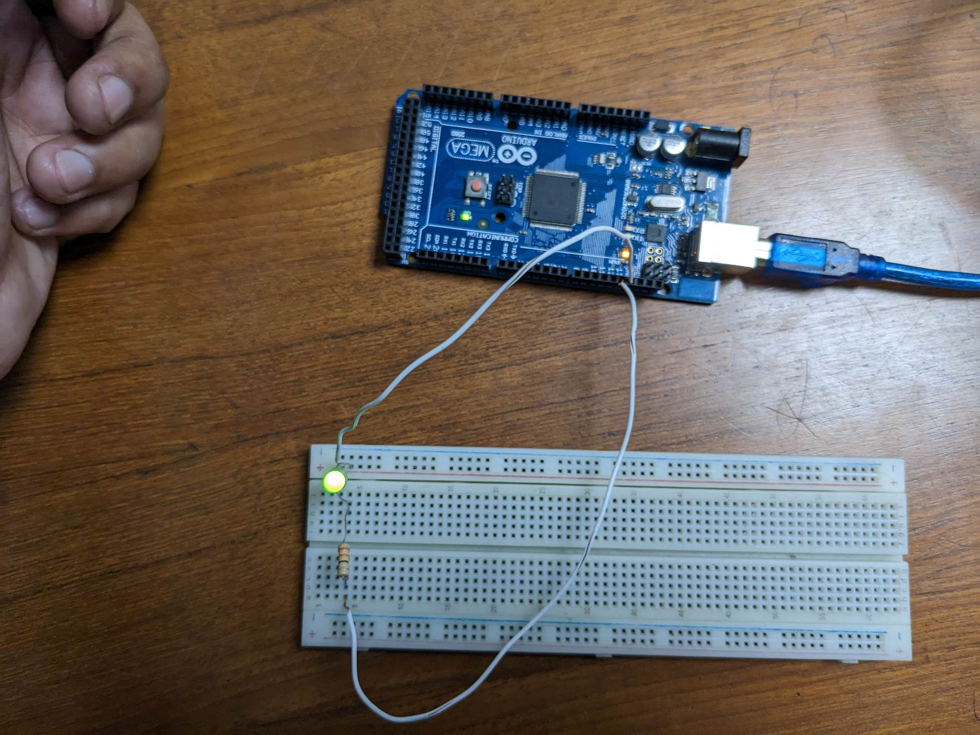

Fig: LED is in on state

**Report:**

All codes, scripts and proteus simulation of the blink program and traffic light system is attached above.



